JUNE 6, 2022
To: Local Business Partner
From: Zachary Lechette, Ph.D., Chief/Public Safety Director
Subject: National Night Out 2022 Sponsorship
Dear Business Owner:
The Landis Public Safety Department, Police Division, is once again excited to participate and host a National Night Out event in Landis. This event takes place across the country on the first Tuesday in August and is a national initiative for police agencies and communities to come together and build lasting relationships.
Last year was the Landis Police Department’s first inaugural National Night Out as a Public Safety Department. We were thrilled with the support and turn-out that we received from members of our community, and we are excited for this year’s event. We hope to have an even bigger and more attended event than last year! Once again, we will be providing various activities for children, families, and the community to come together. Some of the events planned include inflatable bounce houses/obstacle courses, dunk booth, free food and drinks, local vendors, music, helicopter landings, and much more!
The Landis Police Department will be raising money for the Landis Police Foundation, a 501(c)(3) organization, from proceeds gained from the dunk booth and any food donations received (requested but not required). This money will be used later in the year to help fund the police department’s Shop With A Cop program.
To involve as many local businesses in our community as possible in this event, we are inviting businesses to help sponsor some of the activities, either through monetary donations or sponsorship(s) of some of the planned events.
Our primary food donor once again is WoodmenLife, who will be cooking and providing free food to our attendees. We estimate that last year’s National Night Out saw approximately 200 attendees, and we expect this year to have upwards of 300-400 attendees. Some other events which are planned include a car seat safety check, bike helmet fitting and give away, and other local vendors.
Any donation that you may wish to make, or an event or activity that you may wish to sponsor, will be recognized with appropriate signage during the event and subsequent media release. Also, all donations to the Landis Police Foundation are tax-deductible, as it is a 501(c)(3) organization.
If you are unable to sponsor this year but would still like to participate by having a booth at the event, we invite you to do join us!
The event will once again be held at the YMCA, 950 Kimball Rd, China Grove, N.C., from 6 P.M. to 9 P.M., Tuesday, August 2nd, in the soccer fields across from the main YMCA building. The helicopter landings are scheduled to occur at around 7 P.M.
Below are some of examples of sponsorship(s) we are seeking:
- Assorted canned drinks and bottled water
- Sponsorship of rented activities (See below)

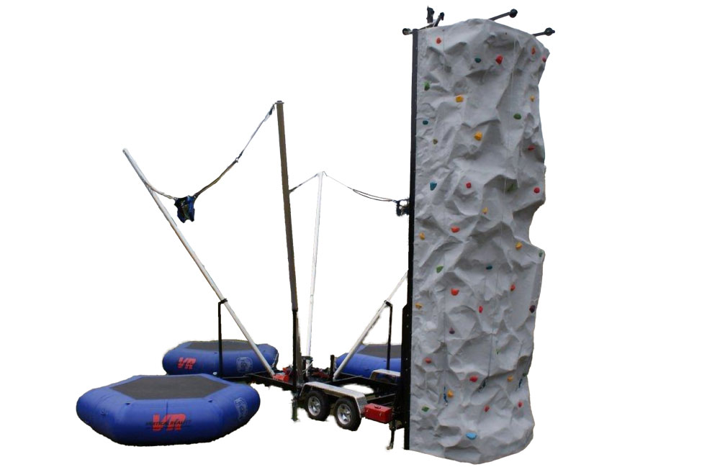COMBINATION ROCKWALL/JUMP STATION $1800
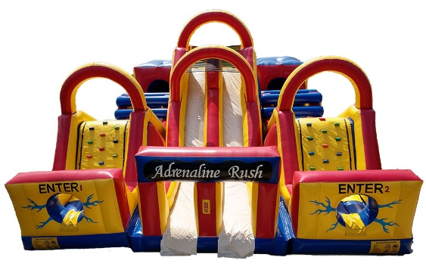 3-PIECE INFLATABLE OBSTACLE COURSE $600
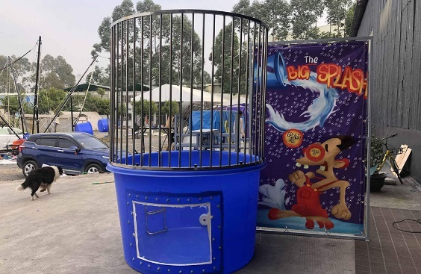 LARGE DUNKING BOOTH $225
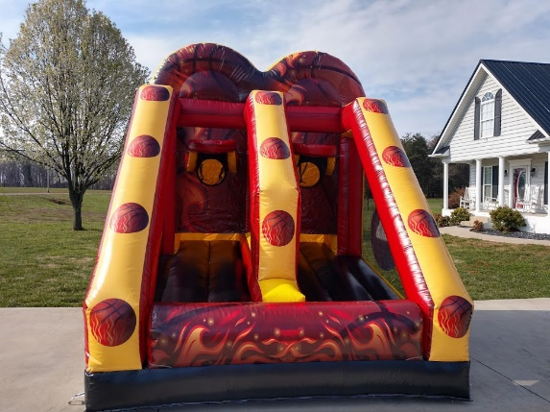 BASKETBALL SHOTOUT GAME $175
- Miscellaneous monetary donations for other needs (fireworks, DJ, etc.)
If you would like to donate and/or sponsor an activity, please make checks payable to the Landis Police Foundation and mail to the address below. Please specify if you are wanting to sponsor a particular item or event. We kindly ask that all donations/sponsorships be made by June 30th to allow adequate planning time.
Landis Police Department
Attn: Chief Lechette
P.O. Box 165
Landis, NC 28088

Please feel free to contact me with any questions or suggestions that you may have. We look forward to another successful community event this year, and with your help, know that it will be even better than last year! Thank you for all that you do for our community!

Respectfully,

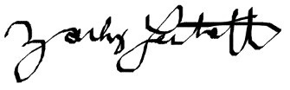
Zachary Lechette, Ph.D.
Public Safety Director,
Chief of Police & Fire Services
zlechette@townoflandisnc.gov
704-857-2129
SPONSORSHIP LEVELS

GOLD SILVER BRONZE
OVER $1,000 $500-$999 UP TO $499

